Go to your instance <https://make.powerapps.com/>. Click on **Import canvas app.**

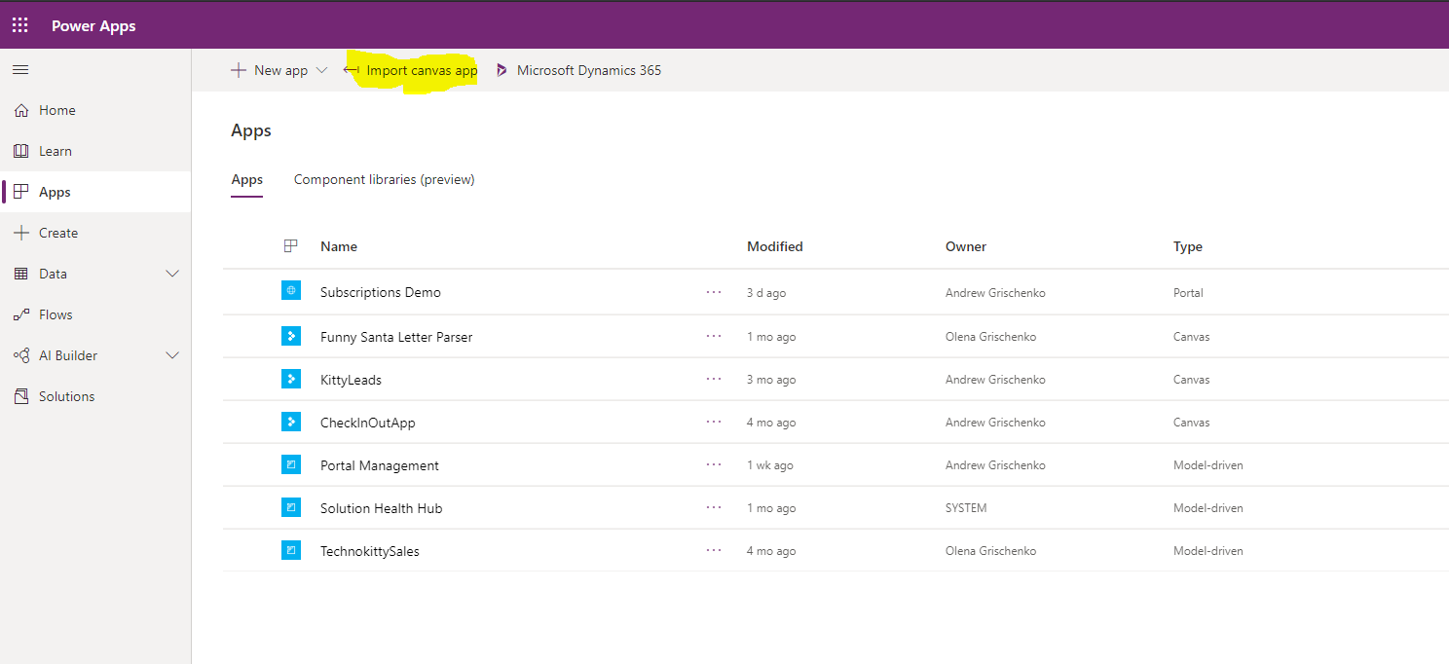

Choose **AIDog-EmotionRecognition_20200620035344.zip** file (package) to be uploaded.

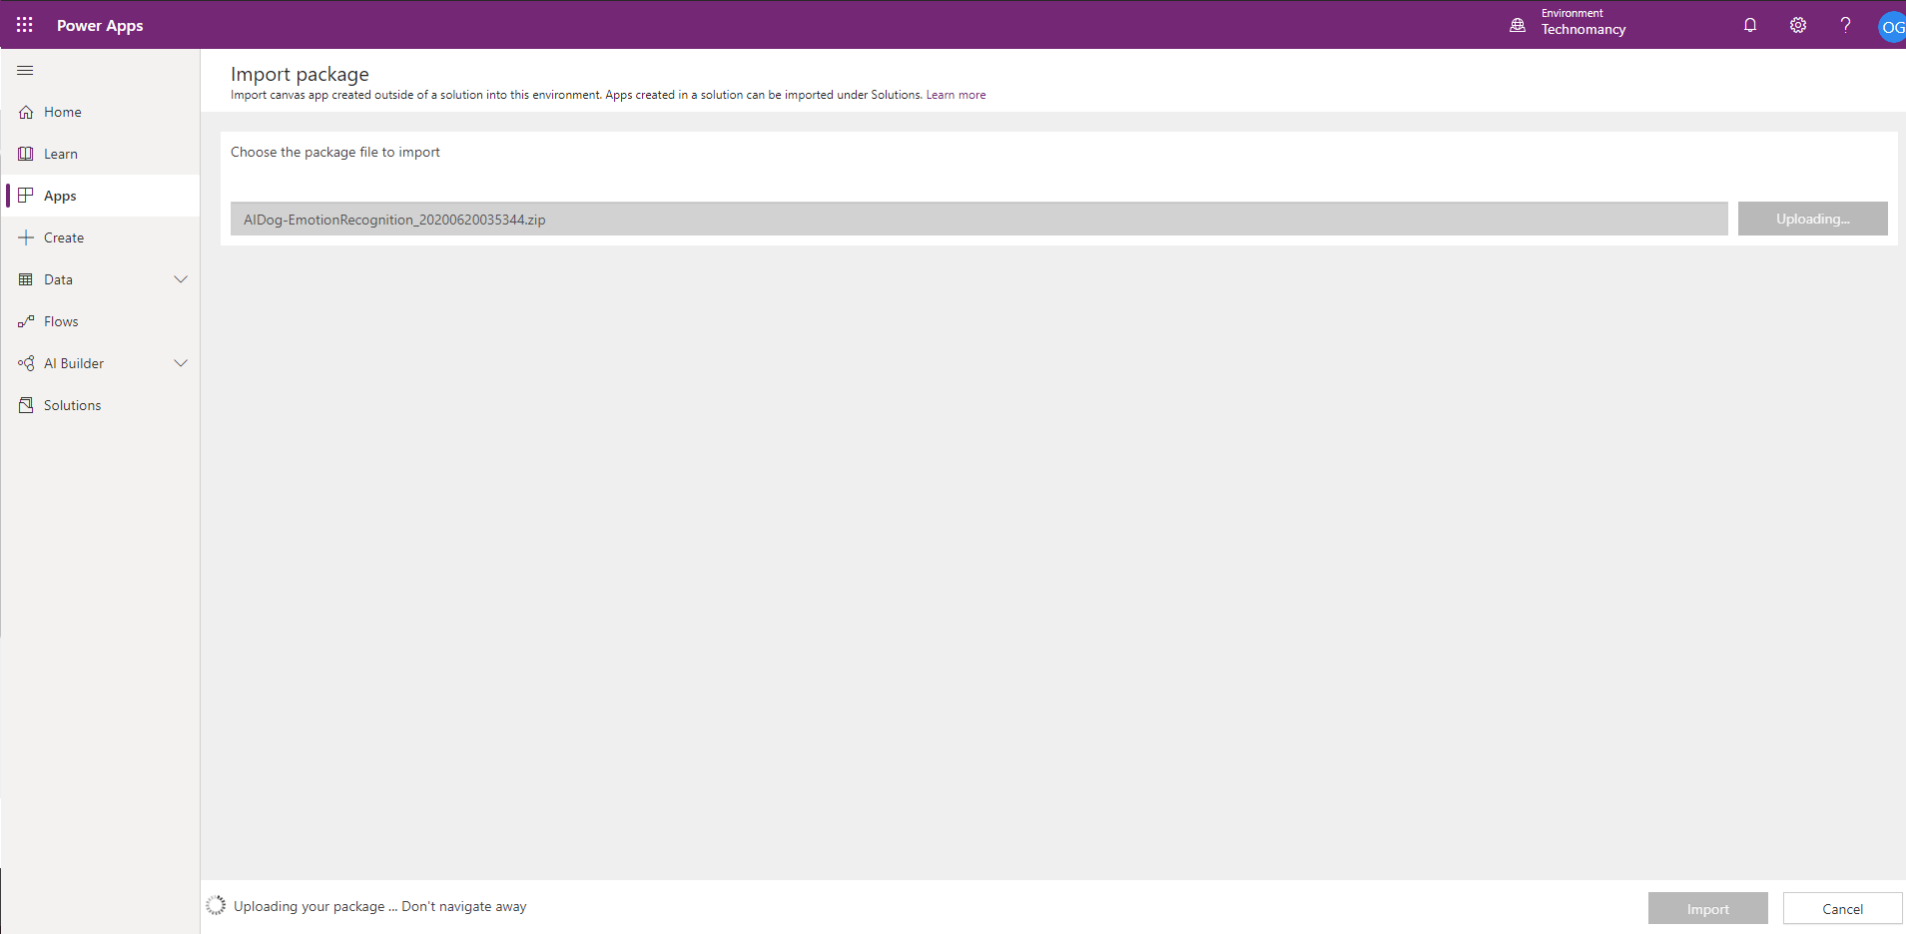

Click **Import**.

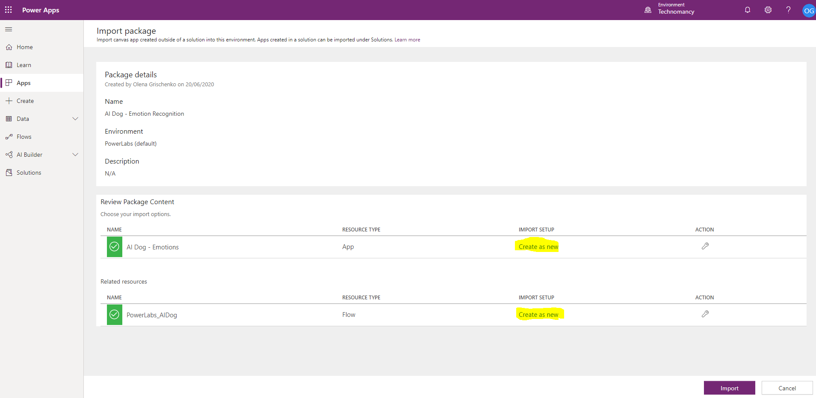

Click on **Open App** to explore the app.

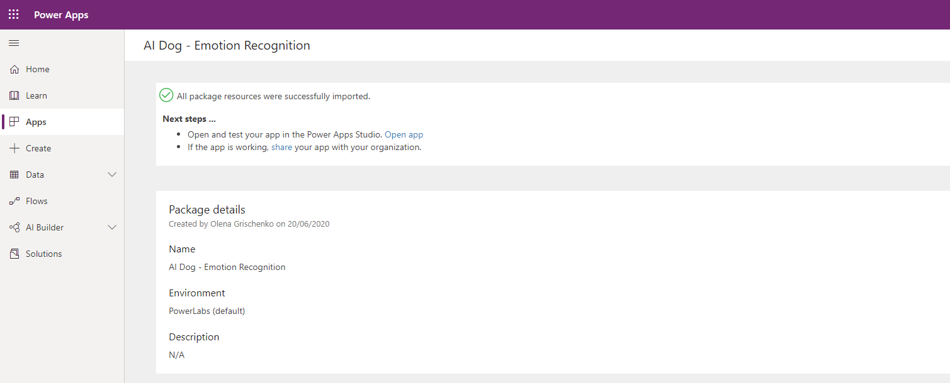

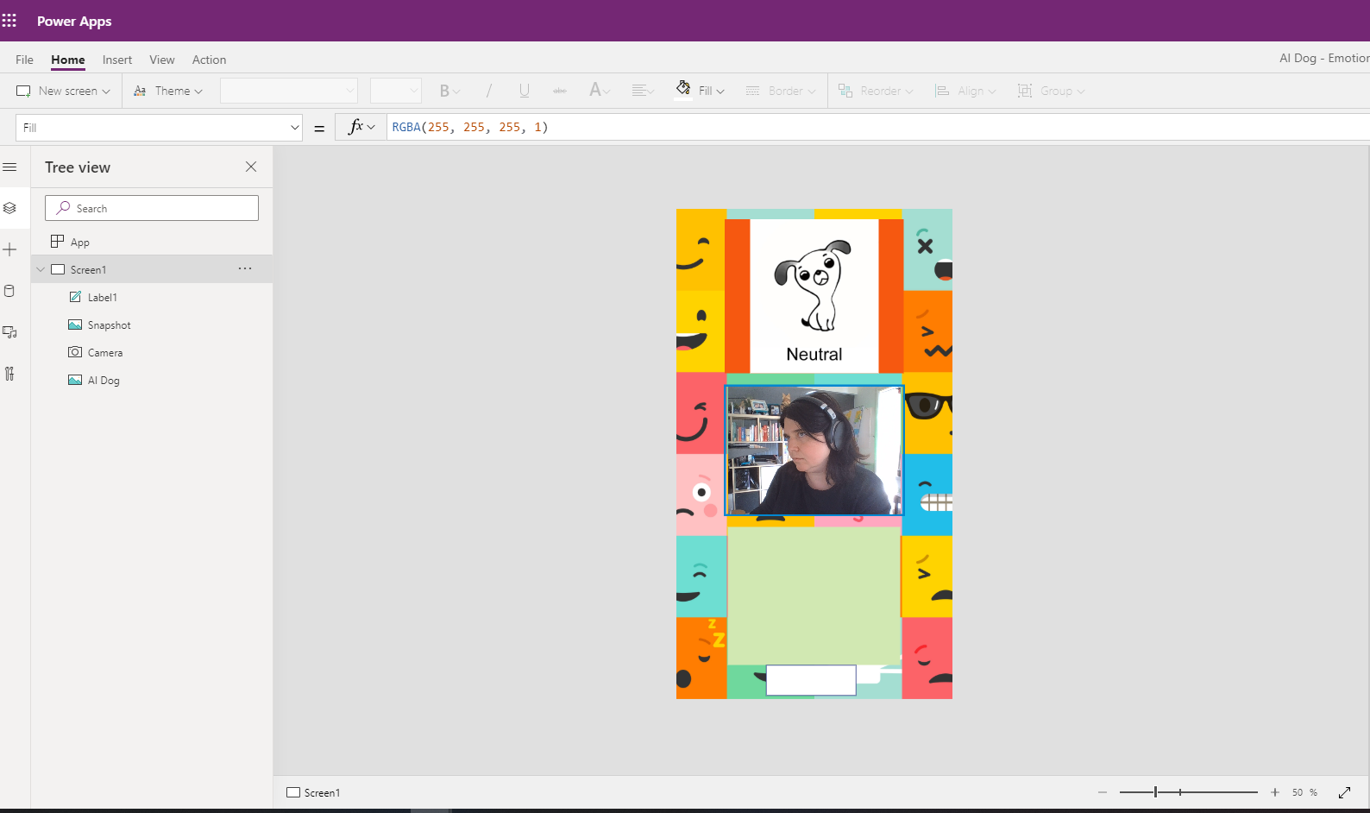

Or go to Flows and open **PowerLabs_AIDog** Flow.

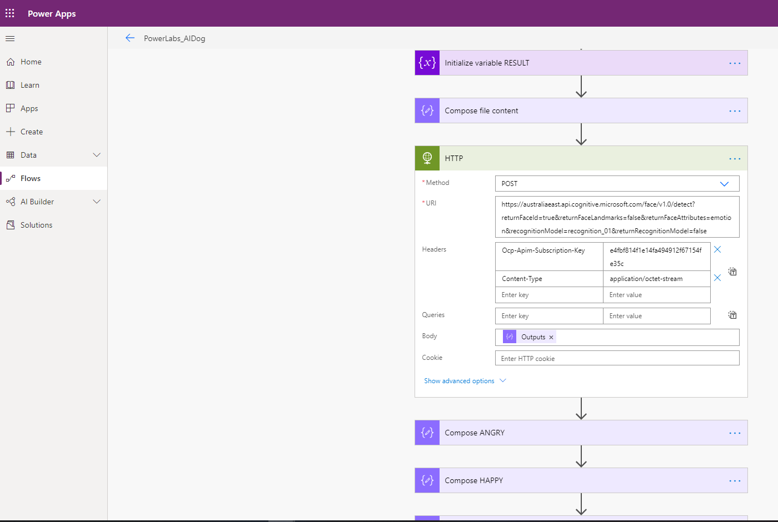

I am aware of the key o Azure Face API which point to my Azure instance remaining in the Flow.

It will be change after 7 days but you can use it complimentary until then.

Happy creating!